**1)Need total sum quantity of the same item in the same location in 1 line instead of few lines**

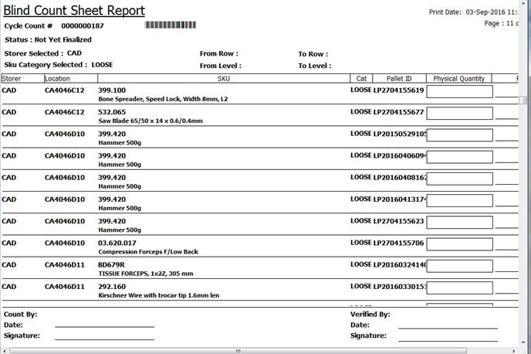

**2)Can arrange for the printing by us to decide of which location instead of print out all of the location.**

**3) please indicate Data Entry to blind count sheet report**

